KORRY complete assembly part no. | 17479-XXXX
cHROMALUX SERIES
switch configuration
MATING CRIMP SOCKET (FOR POKE HOME)
MOUNTING STYLE
MOUNTING PANEL THICKNESS/range (REF)
LAMP CIRCUIT (see sheet 10)
KORRY base assembly part no. | 17479-XXXX
switch action
base type
pin-out type (see sheet 8)
jumpers
SWITCH CONTACT MATERIAL / RATING
KORRY cap assembly  part no. | 17479-XXXX
CAP TYPE
LENS CONFIG (see sheet 9)
SEGMENT | a | B | C | D
legend NOMENCLATURE
legEnd type
(TABLE 1)
ILLUMINATED color
lampS (VOLTAGE)

REVISIONS
LETTER | DESCRIPTION | DATE | APPROVED BY

NOTES
- dRAWING 17479 CONTROLS THE BASIC DESIGN CONFIGURATION OF THIS PART.
- DRAWING 17479 MUST BE USED IN CONJUNCTION WITH THIS DOCUMENT FOR INSPECTION OF THIS PART.
- REFERENCED NOTES, SHEETS AND FIGURES SHOWN ON THIS DRAWING ARE FROM DRAWING 17479.

NOTICE: This document only contains basic marketing information on function or purpose. It does not contain technical data as defined in 15 CFR 772 or 22 CFR 120.10. This document is not subject to U.S. export controls under the EAR or the ITAR

UNLESS OTHERWISE SPECIFIED, DIMENSIONS ARE IN INCHES |  | 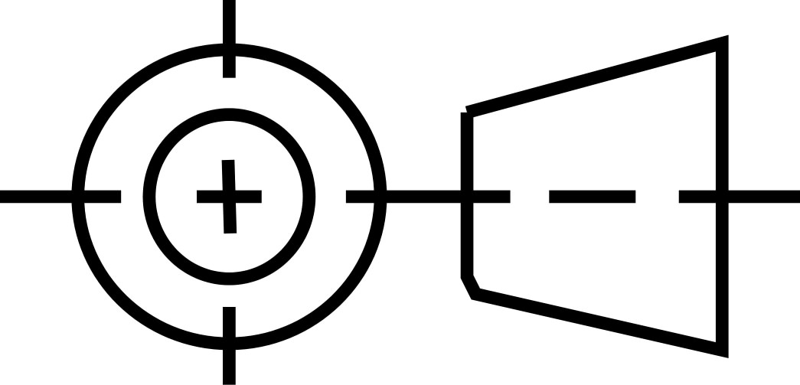  THIRD ANGLE PROJECTION |  | DATE (YYYY-MM-DD): |  | 
 |  |  |  | ESR NUMBER:
 |  |  |  | CUSTOMER:
TOLERANCES ON |  |  |  |  |  | TITLE
2 PLACE | 3 PLACE |  | ANGLES | DRAWN BY | DATE (YYYY-MM-DD) | INDIVIDuAL  PRODUCT FEATURES
±0.030 | ±0.005 |  | ±2°
interpret dim and tol per  asme y14.5m-1994  Interpret drawing per  asme y14.100-2004  NO CHANGES MAY BE MADE TO THIS DRAWING EXCEPT BY ELECTRONIC INPUT TO THE WORD FILE |  |  |  | Engineer | DATE (YYYY-MM-DD)
 |  |  |  |  |  | SIZE | CAGE CODE | DWG NO |  | REV
 |  |  |  | SEE RELEASE RECORD FOR APPROVALS |  | A | 81590 | 17479-XXXX |  | —
 |  |  |  |  |  | SCALE: NONE |  |  | SHEET 1 OF 1

